# VIRTUAL ATM SYSTEM

# MINI PROJECT REPORT

Submitted To the Department of Computer Applications, Bharathiar University in Partial Fulfillment of the Requirement for the Award of The Degree Of

# MASTER OF COMPUTER APPLICATIONS

Submitted by

**K. SUGESH**

**(REG.NO. 22CSEA70)**

Under the guidance of

**Dr. T. AMUDHA, M.C.A., M.Phil., Ph.D.,**

**Professor,**

**Department of Computer Applications** 

**DEPARTMENT OF COMPUTER APPLICATIONS**

**BHARATHIAR UNIVERSITY**

**COIMBATORE – 641046**

**DECEMBER - 2023**

# CERTIFICATE

This is to certify that, this mini project work entitled “**VIRTUAL ATM SYSTEM”** was submitted to the Department of Computer Applications, Bharathiar University in partial fulfillment of the requirements for the award of the degree of **MASTER OF COMPUTER APPLICATIONS**, is a record of original work done by **K. SUGESH (22CSEA70),** during his period of study in the Department of Computer Applications, Bharathiar University, Coimbatore, under my supervision and guidance, and this project work has not formed the basis for the award of any Degree/ Diploma /Associateship/ Fellowship or similar title to any candidate of any University.

**Place: Coimbatore**

**Date:**

Submitted for the University Viva-Voce Examination held on

Project Guide Head of the Department

**Internal Examiner External Examiner**

# DECLARATION

I hereby declare that this mini project work titled, “**VIRTUAL ATM SYSTEM**” submitted to Department of Computer Applications, Bharathiar University, is a record of original work done by **SUGESH K (22CSEA70)**, under the supervision and guidance of

**Dr. T. AMUDHA, M.C.A., M.Phil., Ph.D.,** Professor, Department of Computer Applications, Bharathiar University, and that this project work has not formed the basis for the award of any Degree/ Diploma/ Associateship/Fellowship or similar title to any candidate of any University.

Place: Coimbatore Signature of the candidate

Date: (SUGESH K)

**Countersigned by**

**Dr. T. AMUDHA**

**Professor,**

**Department of Computer Applications,**

**TABLE OF CONTENT**

|  |  |  |
| --- | --- | --- |
| **CHAPTER NO** | **CONTENTS** | **PAGE NO** |
|  | **ACKNOWLEDGEMENT** |  |
|  | **SYNOPSIS** |  |
| **1** | **INTRODUCTION** | 1 |
|  | 1.1 OVERVIEW OF THE PROJECT | 1 |
|  | 1.2 MODULE DESCRITPION | 2 |
| **2** | **SYSTEM SPECIFICATION** | 3 |
|  | 2.1 HARDWARE REQUIREMENT | 3 |
|  | 2.2 SOFTWARE REQUIREMENT | 3 |
| **3** | **SYSTEM ANALYSIS** | 4 |
|  | * 1. EXISTING SYSTEM | 4 |
|  | * 1. PROPOSED SYSTEM | 4 |
|  | * 1. FEASIBILITY STUDY | 5 |
|  | 3.3.1 TECHNICAL FEASIBILITY | 5 |
|  | 3.3.2 OPERATIONAL FEASIBILITY | 5 |
| **4** | **SYSTEM DESIGN** | 6 |
|  | 4.1 INPUT DESIGN | 6 |
|  | 4.2 OUTPUT DESIGN | 7 |
|  | 4.3 DATAFLOW DIAGRAM | 9 |
|  | 4.4 SCREENSHOTS | 10 |
| **5** | **SYSTEM TESING** | 30 |
| **6** | **CONCLUSION AND FUTURE ENHANCEMENT** | 31 |
|  | **REFERENCES** | 32 |

# ACKNOWLEDGEMENT

I have taken efforts in this project. However, it would not have been possible without the kind support and help of many individuals and organizations. I would like to extend my sincere thanks to all of them.

I express my sincere gratitude to our Professor & Head of the Department **Dr. M. PUNITHAVALLI, M.Sc., M.Phil., Ph.D.,** Department of Computer Application, Bharathiar University, Coimbatore, thanks to department faculty members and guest faculties supported to acquire knowledge from various inputs. I am forever indebted to this mini project guides **Dr. T. AMUDHA, M.C.A., M.Phil., Ph.D.,** Professor**,** Department of Computer Applications, Bharathiar University for providing valuable suggestions and always been enthusiastically guiding us throughout the project.

Finally, I also extend my special thanks to my family, friends, who have kindly provided the necessary support for the successful completion of the project and their moral support.

# SYNOPSIS

The project titled “**VIRTUAL ATM SYSTEM”** is used to access their bank accounts and user has to select a menu from the options displayed on the screen. The menus are related to withdrawal, deposit, check the balance, and pay loan. Whenever the user needs to make cash withdraw, they can enter their PIN number (personal identification number). If a transaction fails for an invalid PIN, the ATM will display an error message and then ask the customer whether he/she wants to do another transaction. It will display the available denomination in the form of 100’s 200’s and 500’s.

Once their withdrawal was successful, the amount will be debited in their account and the receipt will be printed. The ATM will provide the customer with a printed receipt for each successful transaction, showing the date, time, type of transaction, amount, and ending available balance(s).

To deposit the money, user need to deposit the amount, amount will be credited in their account and user can view the deposited receipt. If user wants to check the available balance in their account, they can click the balance option. In addition, bank loan payment such as housing loan, personal loan, and business loan options are provided to pay the loans and user can also view the loan paid receipt.

**1.INTRODUCTION**

**1.1 OVERVIEW OF THE PROJECT**

The main purpose of this project is mainly focusing on the new feature that can be implemented as a possible alternative to the traditional methods. Automated Teller Machine (ATM) has been working for a long term, providing all the required features for the customers to use such as withdrawing money or cash deposits. Based on the traditional methods in banking system, the bank will appoint a person, the teller to assist the customers. when the customers need to perform any services in a bank. The customers on the other hand, will need to request for forms and the forms will be submitted to the counter. In order to perform, customers will need to queue up the line while waiting for their turns. ATM refers to a machine that acts as a bank teller by receiving and issuing money to and from the ATM account holders/users (Singh, 2009). In this new era of technology, ATM machine was used as a convenient way of getting his money from banks. These customers would not have to queue for longer lines while waiting for their turns but instead, these customers only need their ATM cards to perform such services.

A person will no longer have to carry a wallet-full of paper money, or in the other terms, cash along to where the customers want to go. Customers will only need the ATM card, insert it in the slot of the machine without having any required form to perform their wanted services.

ATM is designed to perform the most important functions of the bank. By using plastic cards, containing all personal details of the customers and they will only need to enter their pin numbers in order to use the services. ATM is an Electronic Fund Transfer that is capable of handling many functions, until when a person loss his ATM cards. Instead of using the traditional methods which are queuing up the line and by hotline phone call, this could be the possible alternative adding the new feature on the ATM machine, where it could be less time consuming.

**1.2 MODULE DESCRITPION**

**User Authentication Module**

* Responsible for securely authenticating users before allowing access to the Virtual ATM.
* Implements multi-factor authentication to enhance security.
* Manages user credentials and ensures the confidentiality of sensitive information.

**Transaction Processing Module**

* Manages a variety of financial transactions, such as withdrawals, deposits, fund transfers,

and balance inquiries.

* Implements security measures to safeguard transactions and prevent unauthorized access.

**Receipt Generation Module**

* Generates electronic receipts for each transaction, providing users with a record of their

financial activities.

**Transaction History Module**

* Maintains a comprehensive record of user transactions for reference and auditing purposes.
* Enables users to view their transaction history and filter transactions based on criteria.

**Account Management Module**

* Handles user account information, including account creation, updating personal details,

and account deletion.

* Validates user account status and permissions for different transactions.

**2. SYSTEM SPECIFICATION**

**2.1 HARDWARE REQUIREMENT**

#### System : Laptop

* + - * + Processor : Ryzen 5

#### Hard Disk : 500GB

* + - * + RAM : 8GB (For good results)

**2.2 SOFTWARE REQUIREMENT**

#### Operating System : Windows 11

#### Front End : JAVA (JDK 8.0)

#### Front End Tool : NETBEANS 8.2 IDE

* Back End : MySQL (Version 8.3.30)

**3. SYSTEM ANALYSIS**

* 1. **EXISTING SYSTEM**

Existing system creates complexity in doing calculation of collection of money because it is manual. Existing system creates problems in maintaining records of book keeping. Existing system, there is large documentary work so it requires space for its storage. To do the documentary work there is need of extra staff worker. Existing system takes much more time to updating process of records. Due to existing system crowding of customer in bank premises are more &pressure of work on bank servants are also more need for the new system.

* 1. **PROPOSED SYSTEM**

The system customer transactions, satisfies the requirements of the existing system in full- fledged manner. Through this system, customer can make fast transactions and view the last transactions easily and pay the loan in atm system itself.

The proposed system needs to maintain all the records in computerized form. It is useful to store record systematically & accurately by using this system. It is useful to reducing the extra work which maintains the records of bookkeeping & paper less work. We can easily handle data efficiently & effectively. The storage space, extra workers, missing files all these possibilities are decreased through this system.

This system helps to save time & cost spending on documentation. With the help of this system ATM card holder can see all the records about his account only at any time efficiently. The most important facility provided by this system is that, there is no any possibility of miss any records. This system is useful for recording daily transactions done by customers.

## FEASIBILITY ANALYSIS

## 3.3.1 TECHNICAL FEASIBILITY

The technical feasibility study always focuses on the existing computer hardware, software and personal. This also includes need for more hardware, software or personal and possibility of procuring or installing such facilities.

ATM is a system that can work on single stand alone Pentium machine with 128 MB RAM, Hard disk drive size of 80 GB, mouse, monitor and keyboard & it also require internet connection to corresponding computer. The equipment are easily available in the market, so technically the system is very much feasible.

## OPERATIONAL FEASIBILITY

It is also known as resource feasibility. The operation users of the system are expected to have minimum knowledge of computer. The developed system is simple to use, so that the user will be ready to operate the system. The proposed system is developed using JAVA programming language & MySQL database which is platform independent and user friendly. So, the system is operationally feasible.

**4.SYSTEM DESIGN**

**4.1 INPUT DESIGN**

Input design is a crucial phase in the system development life cycle (SDLC) and user interface design process. It involves defining how users will input data into a system, ensuring that the input methods are user-friendly, efficient, accurate, and meet the requirements of the system. The goal of input design is to create an interface that enables users to interact with a system effectively, providing a positive user experience.

Designing the input system for a virtual ATM involves creating a user interface that is intuitive, secure, and efficient. Here's a basic outline of input design for a virtual ATM:

1. **User Authentication**
   * Start with a secure login screen.
   * Use a combination of username/password, PIN, and possibly biometric authentication (fingerprint, facial recognition) for enhanced security.
2. **Main Menu**
   * Once authenticated, display a clear and concise main menu.
   * Include options such as:
     + Withdrawal
     + Deposit
     + Balance Inquiry
     + Loan
3. **Transaction Forms**
   * When a user selects a transaction, present a clear form with fields for necessary input.
   * For withdrawals, include fields for amount and account selection.
   * For deposits, include fields for deposit amount and account selection.
   * Validate inputs in real-time to prevent errors.
4. **Amount Entry**
   * Design a numeric keypad for entering amounts.
5. **Receipt Options**
   * Allow users to choose receipt options for each transaction (print, receipt).
   * Provide a summary of the transaction details in the receipt.
6. **Security Measures**
   * Implement time-out sessions for security.
   * Use secure connections (HTTPS) to protect user data during transactions.
7. **Exit Option**
   * Include a prominent Cancel or collect option to ensure user sessions are properly terminated.
8. **Screen size**
   * Fixed screen size.
9. **Testing**
   * Conduct thorough usability testing with real users to identify and address any potential issues.

Effective input design is essential for creating a positive user experience and improving overall system usability. It requires collaboration between system designers, developers, and end-users to understand the context of use and design input mechanisms that align with user expectations

**4.2 OUTPUT DESIGN**

Output design is a critical aspect of the user interface design process that focuses on how a system presents information and results to users. For a Virtual ATM system, the output design is essential in delivering clear, informative, and visually appealing feedback to users.

1. **Transaction Confirmation**
   * Clearly display a transaction confirmation message after each successful transaction.
2. **Receipt**
   * Provide an option for users to receive a digital or printed receipt.
   * If a receipt is chosen, display a summary of the transaction with all relevant details.
   * Ensure that the receipt includes a transaction reference number for future reference.
3. **Balance Information**
   * After each transaction, update and display the account balance.
   * Show the previous balance, the transaction amount, and the new balance.
   * Include a clear indication if the transaction resulted in a balance change.
4. **Menu Navigation**
   * Clearly present the main menu options after authentication.
   * Highlight the selected menu option and provide visual cues for navigation.
5. **Transaction History**
   * Allow users to view their transaction history.
   * Display a list of recent transactions with details such as date, time, transaction type, and amount.
6. **Logout Confirmation**
   * When users choose to cancel button, display a confirmation message to ensure they intended to end their session.
7. **Visual Design**
   * Use a clear and visually appealing layout for all output screens.
   * Ensure text is easily readable and use intuitive icons where applicable.
8. **Responsive Design**
   * If the virtual ATM is accessible through various devices, ensure responsive design to accommodate different screen sizes.

Output design is a crucial phase in the system development life cycle (SDLC) and user interface design process. It focuses on determining how a system presents information to users or other systems in a clear, meaningful, and effective manner. The goal of output design is to deliver information, results, and feedback in a format that is easy to understand, aids decision-making, and enhances the overall user experience.

## 4.3 DATAFLOW DIAGRAM

## 

## 

## 4.4 SCREENSHOTS

## 

* Below screen is the main display of the ATM Management system.

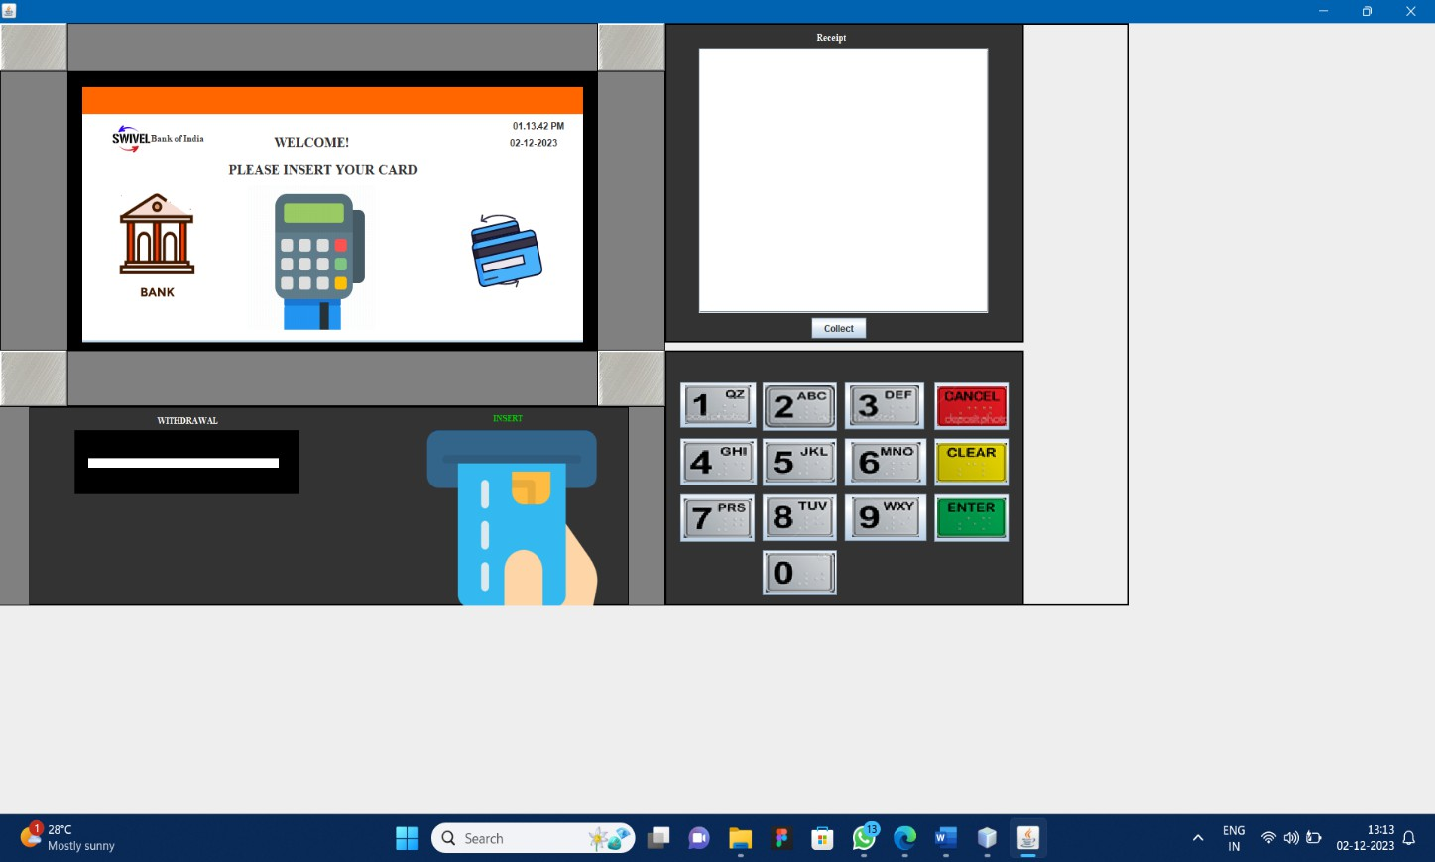

## Fig 4.4.1 main display of the atm simulator

* Once the user insert the ATM card in the machine it will ask the user to enter the PIN which has been set by the customer.

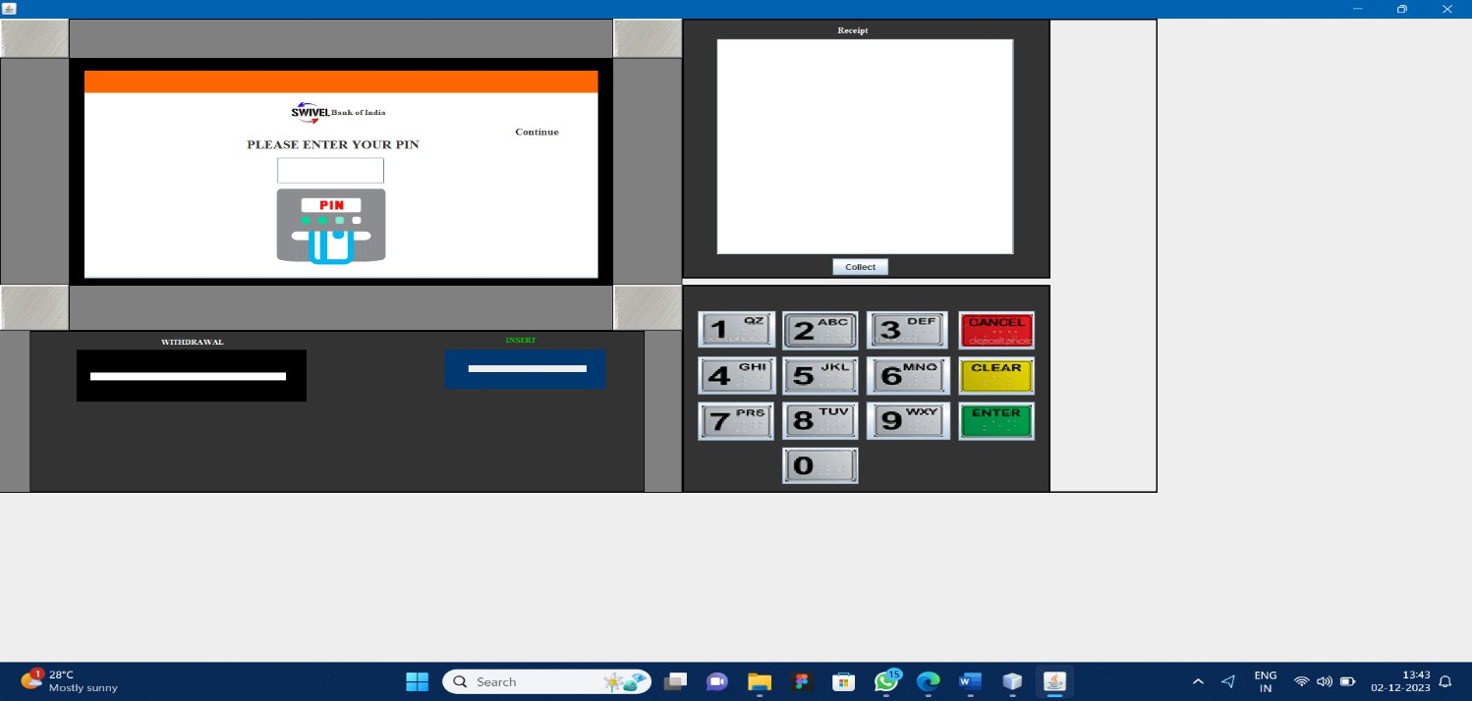

Fig 4.4.2 Pin Function

* + If the user entered the wrong pin then it will show the error message as “Incorrect Pin Number” in the main display and to home page.

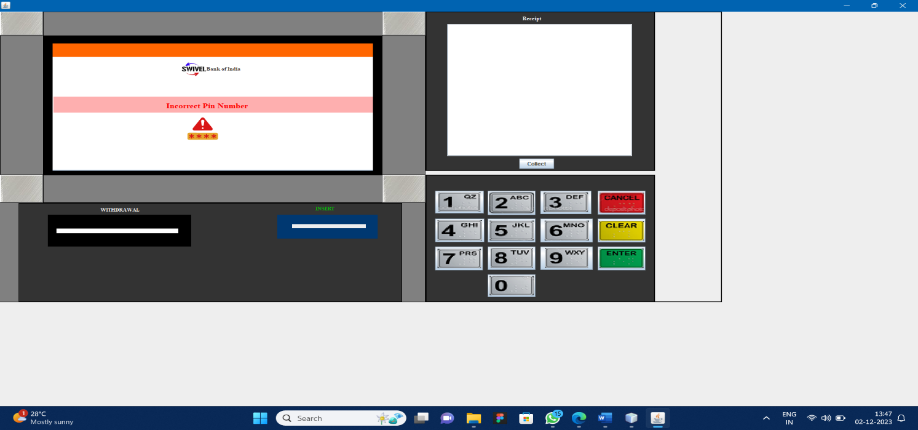

Fig 4.4.3 Incorrect Page

* + - If the user entered the correct pin then it will go the page where it will allow the user to select the module that they need to use.
    - As we said earlier it will display the four modules.

1. Deposit
2. Balance inquiry
3. Withdrawal
4. Loan - to make a selection.

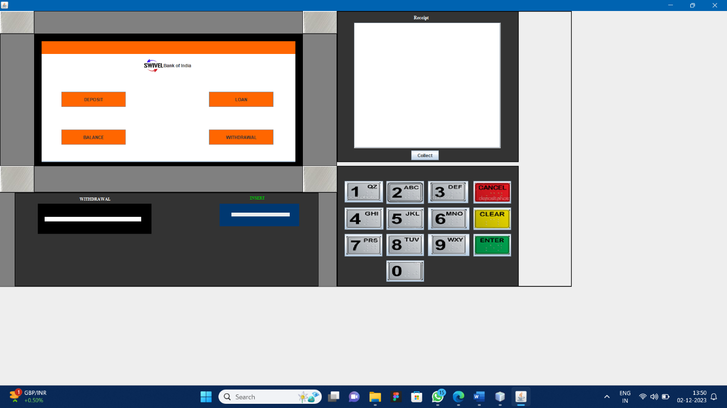

Fig 4.4.4 Module Page

## DEPOSIT:

* + If they touch and select Deposit as their option it will ask the user to enter the amount that needs to be deposited on that particular account.

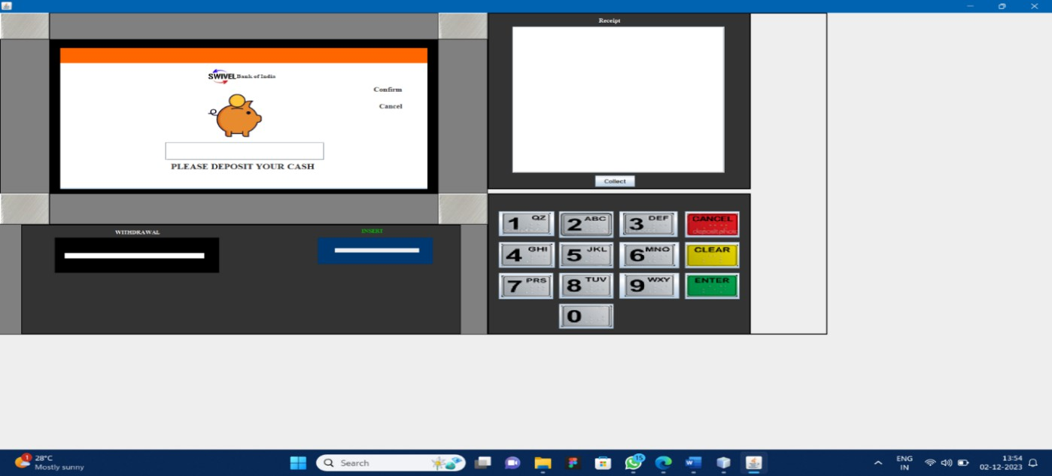

Fig4.4.5 Withdrawal page

* + If they select the option of Balance it will display the customer name and the balance in their account in the display.

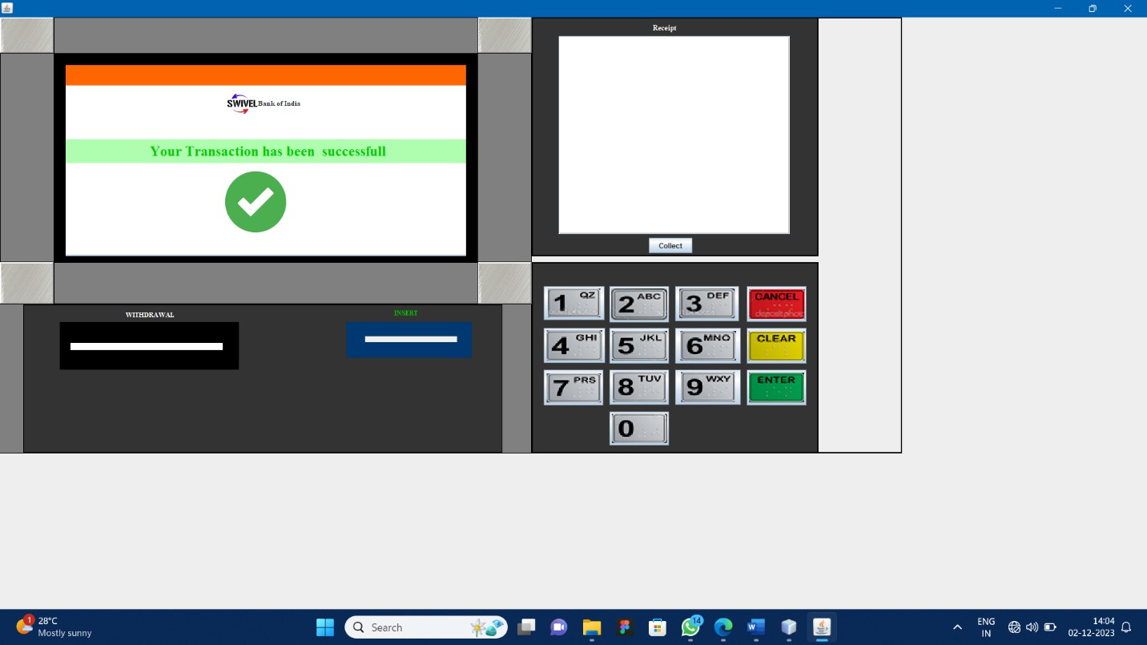

Fig4.4.6 Withdrawal

* + Once you enter the deposit value and gives Confirm then it will show the success message as” Your transaction has been successful” in the main display.
  + It will ask whether you want to print the receipt If yes it will print the receipt for the user.

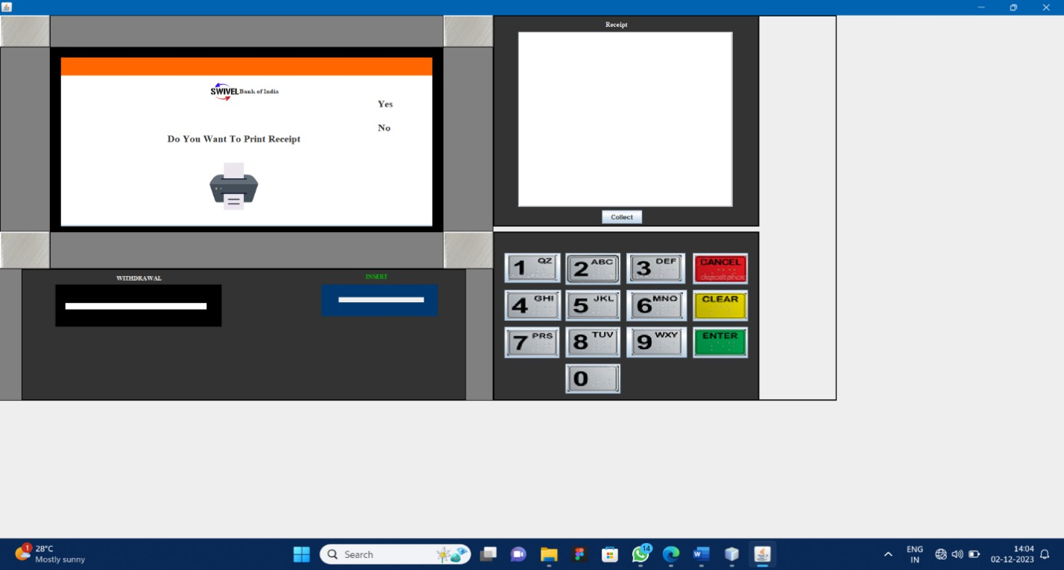

Fig 4.4.7 Receipt page

* + If select the “YES “Option it will print the receipt.
  + 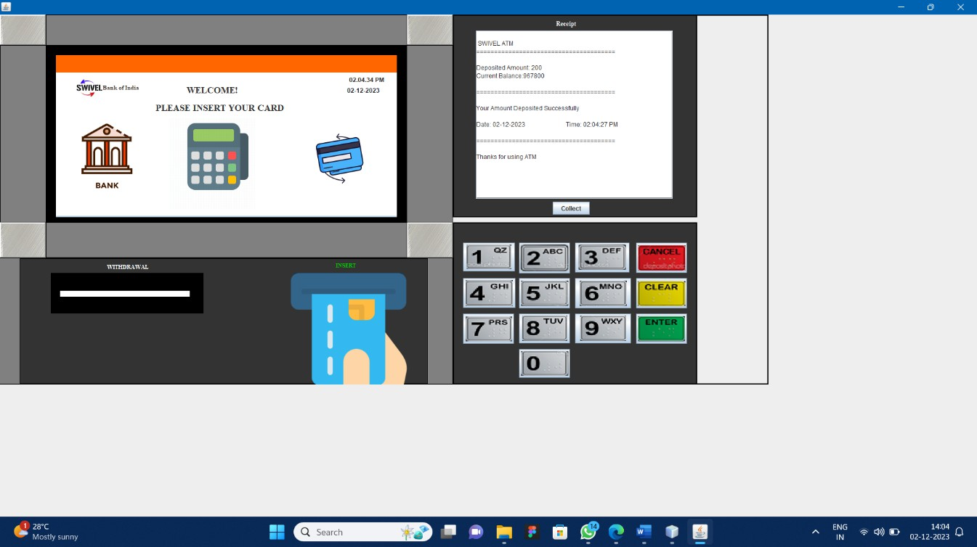And also it will ask the user to take out the card and display the messages “Thank you Visit again” in the home page. if they choose No it will return to home page it will ask the user to take out the card and display the messages “Thank you Visit again”.

Fif 4.4.8 Main Page

## BALANCE:

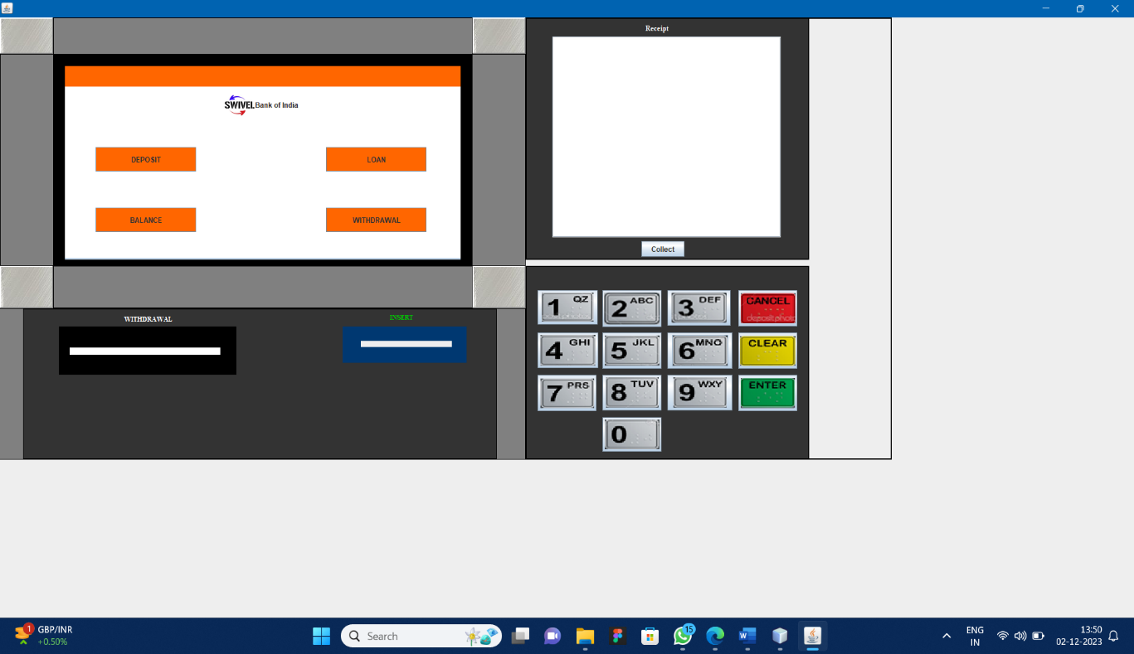

Fig 4.4.9 Module page

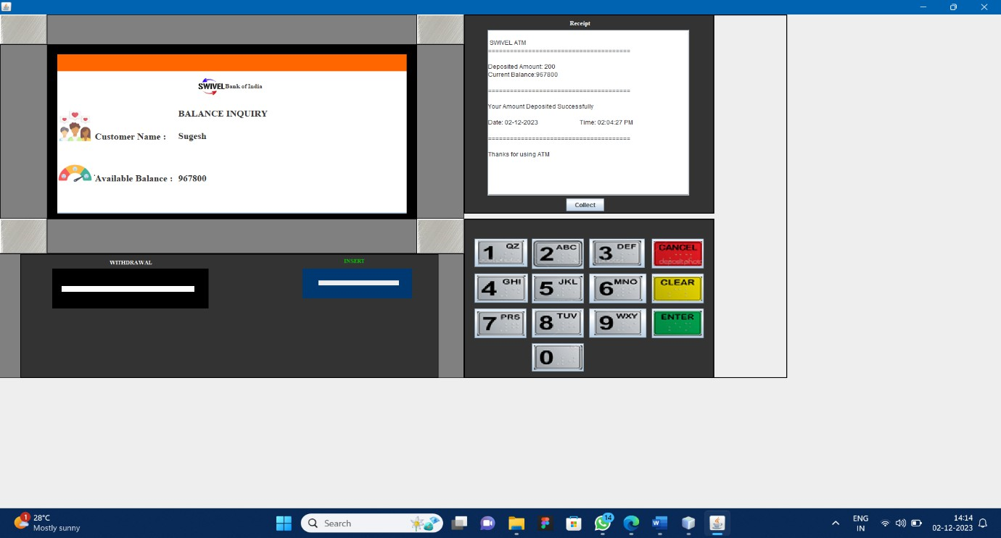

Fig 4.4.10 Balance page

## WITHDRAWAL:

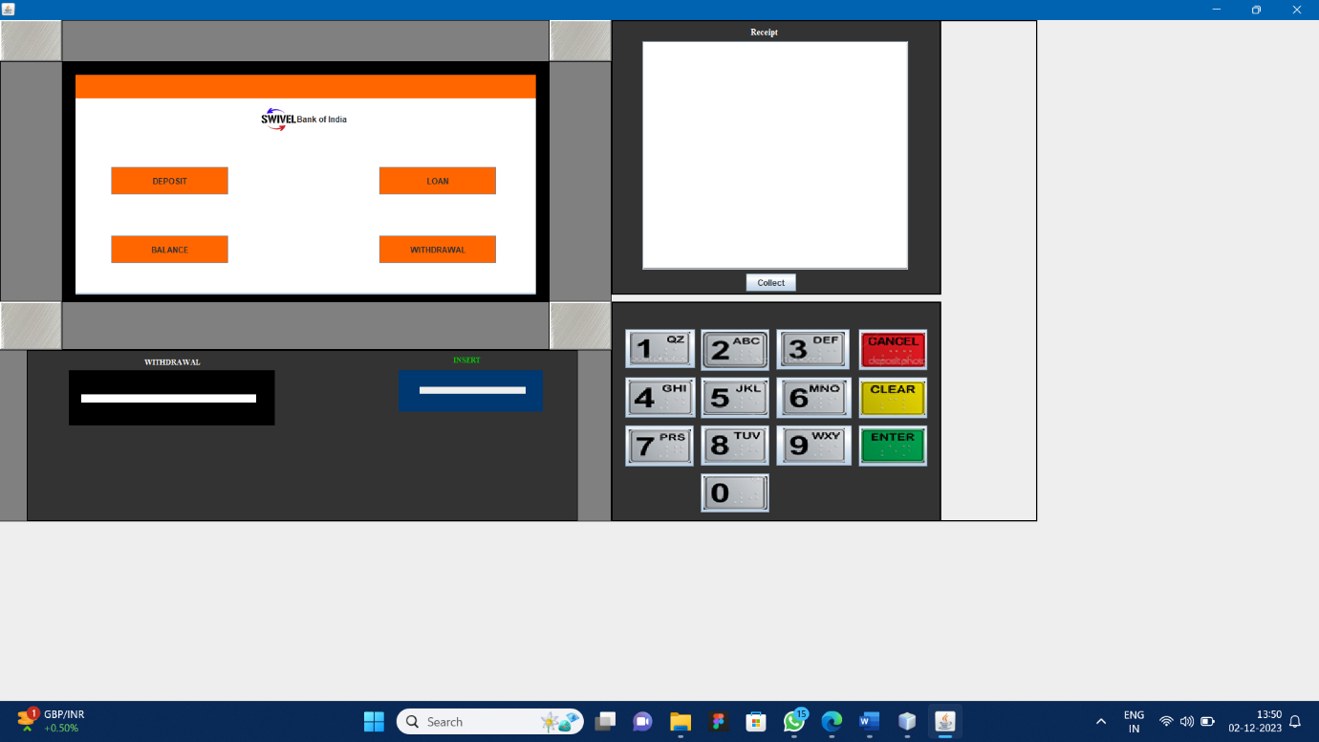

Fig 4.4.11 Module Page

* + If they the select the option withdrawal it will ask the user to enter the amount need to be withdrawn from the account once they entered the amount and click to confirm.

.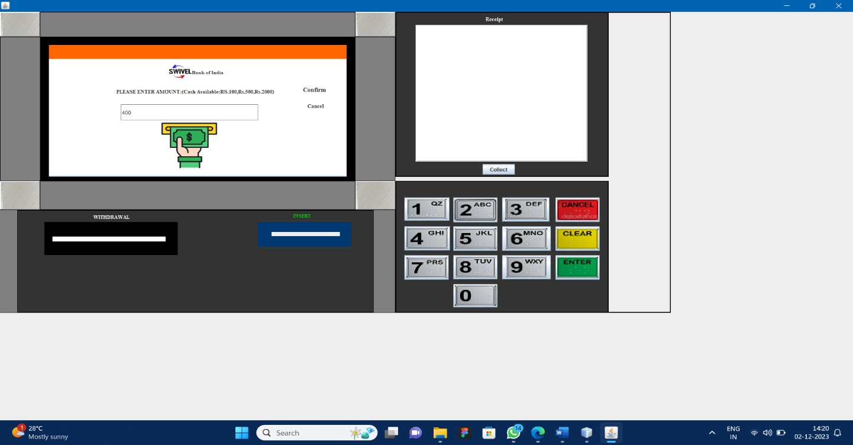

Fig 4.4.12 Amount page

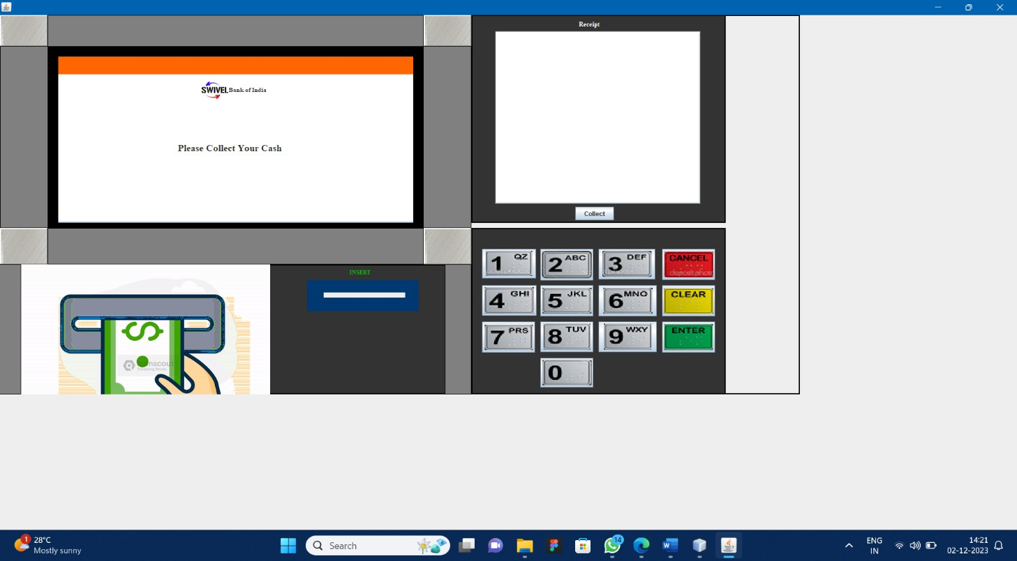

Fig 4.4.13 money Collection page

* + - The amount has been collected by the user it will show message as “**your Transaction has been successful**”.

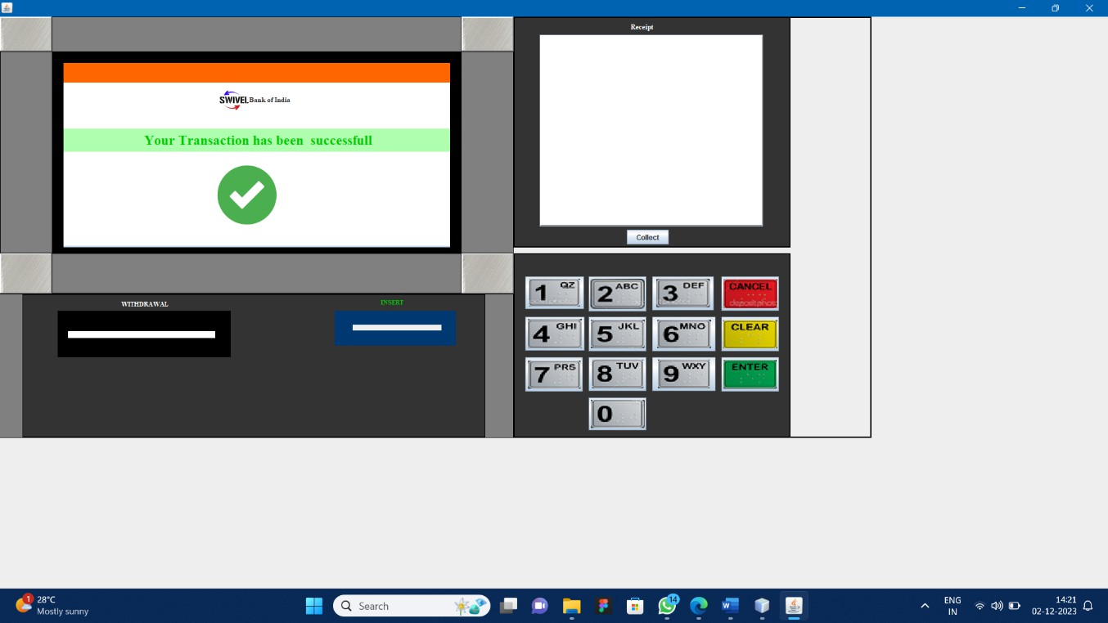

Fig 4.4.14 Success Page

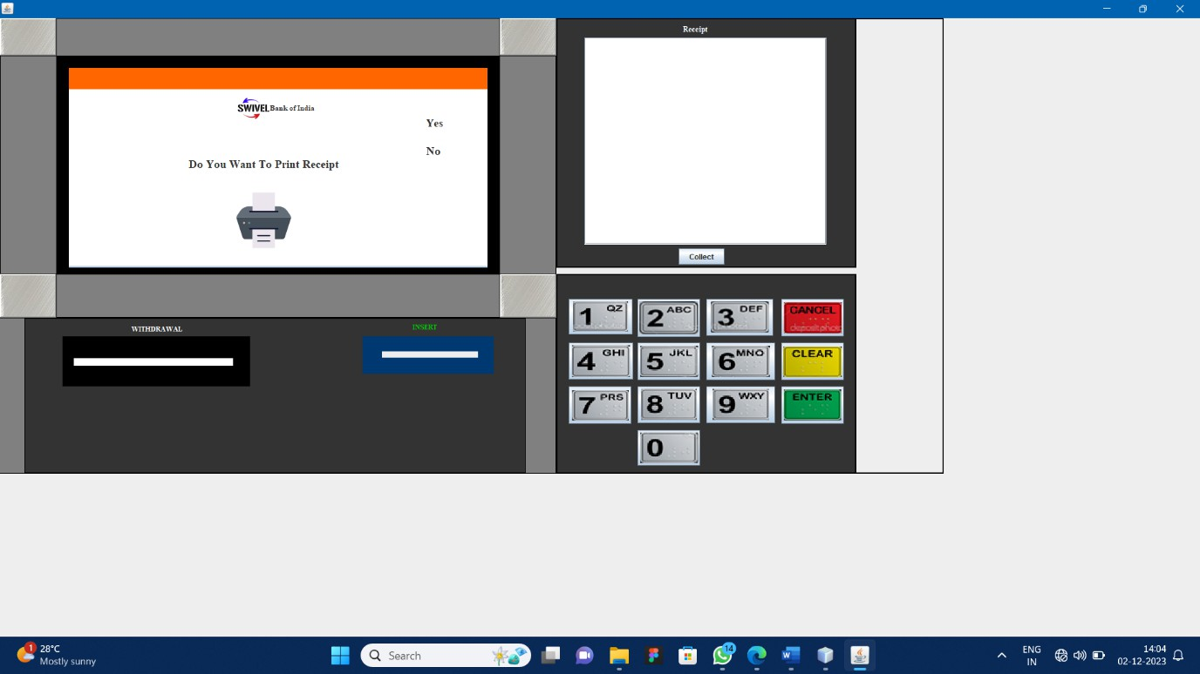

Fig 4.4.15 Receipt Page

* + - And also it will ask the user to take out the card and display the messages “Thank you Visit again” in the home page. if they choose No it will return to home page it will ask the user to take out the card and display the messages “ Thank you Visit again”.

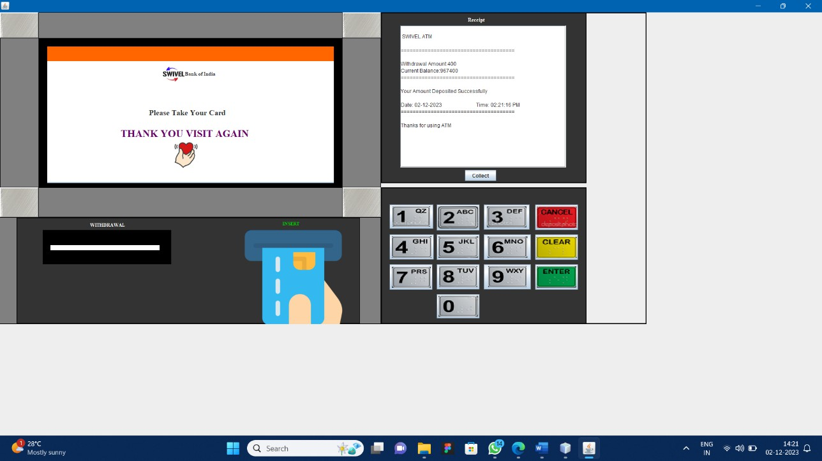

Fig 4.4.16 details Page

## 4.LOAN:

* + If they choose option as Loan, It will ask them to choose the type of Loan user preferred to avail,

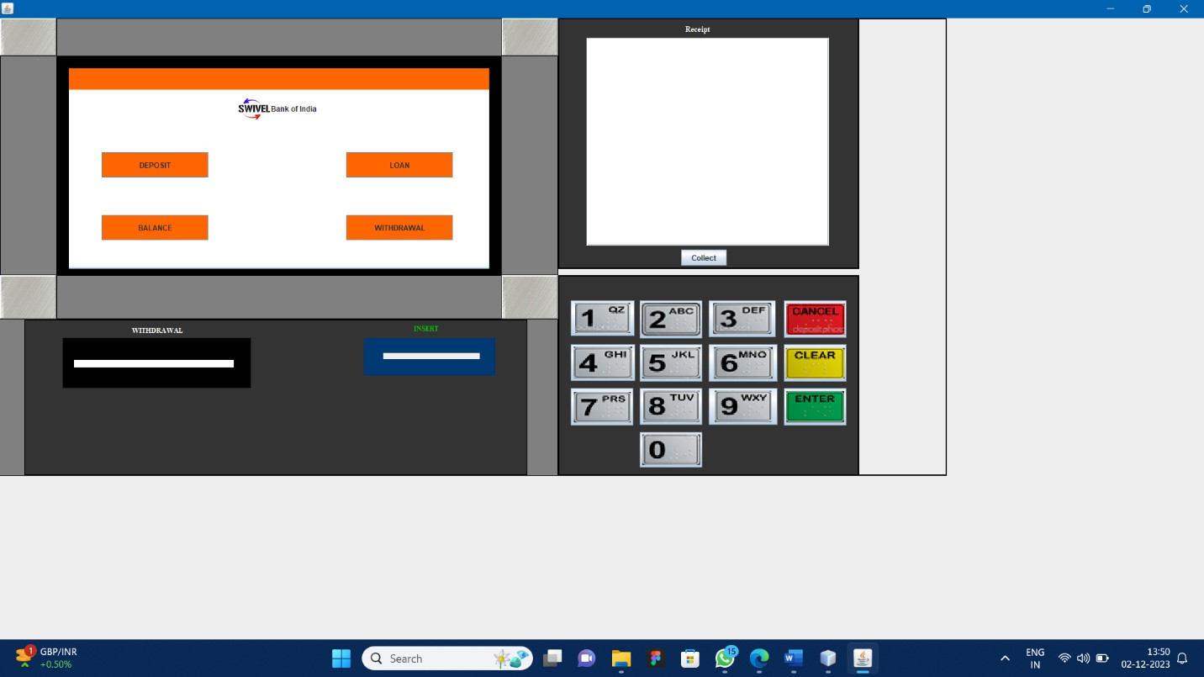

Fig 4.4.17 Module Page

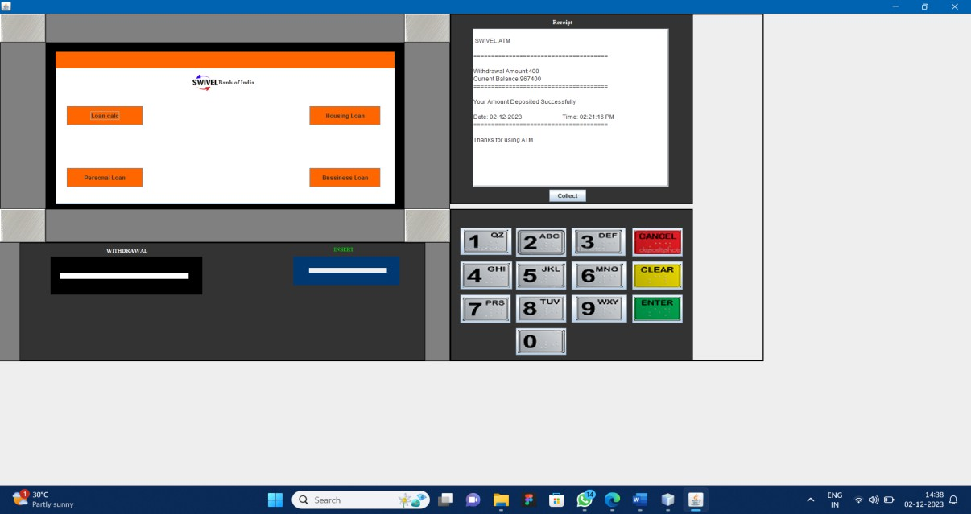

Fig 4.4.18 Loan list Page

* They are Various loan option
  + 1. Loan Calculator.
    2. House Loan.
    3. Personal Loan.
    4. Business Loan.
  + If the user choose **Loan calculator,**

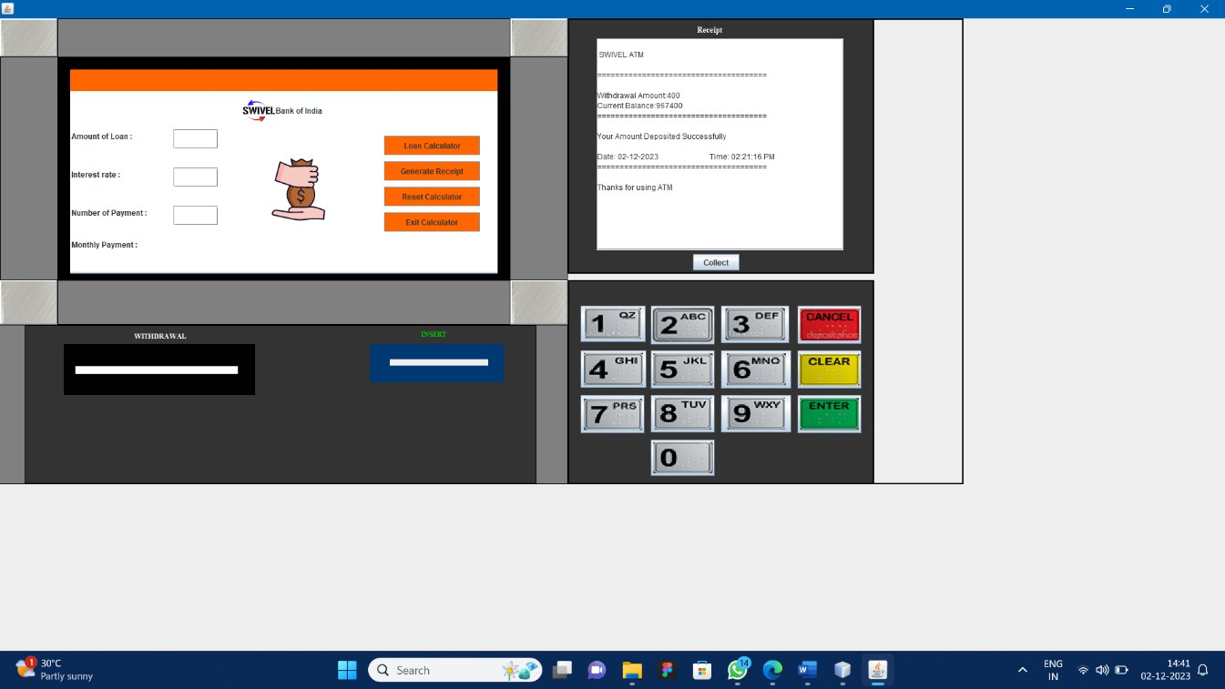

Fig 4.4.19 calculator Page

* + It will ask the user to enter how much amount they want as a loan, the percentage of interest and the Number of payments

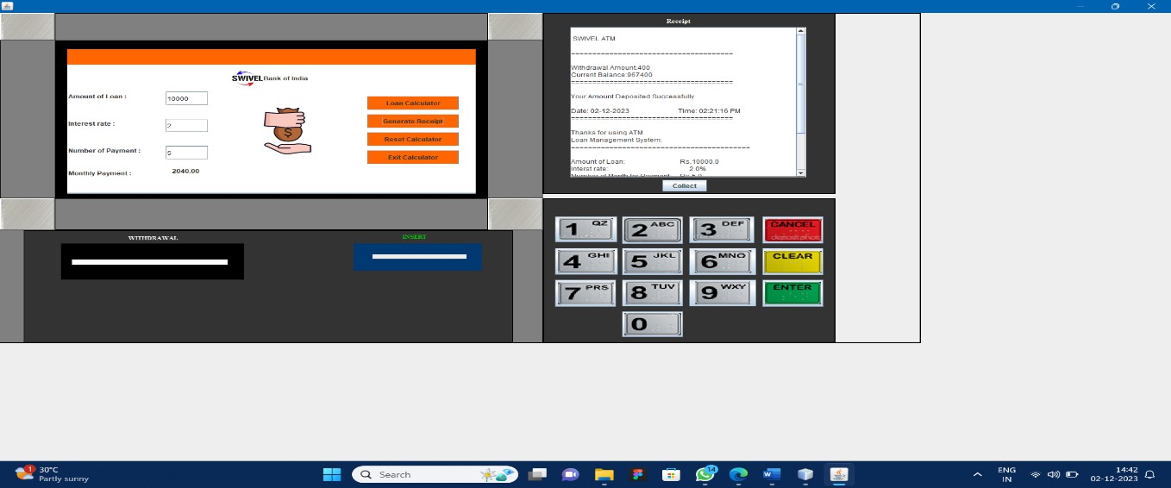

Fig 4.4.21 Result page

* + And click on Loan Calculator button so that the application will calculate the amount automatically and display it on the Monthly payment tab.
  + Also we have receipt option here to print the calculation for their reference.
  + We have Reset option in the same page this will clear all the fields in that page
  + If they give exit it will return to home page.

**HOUSING LOAN:**

* If they choose House loan

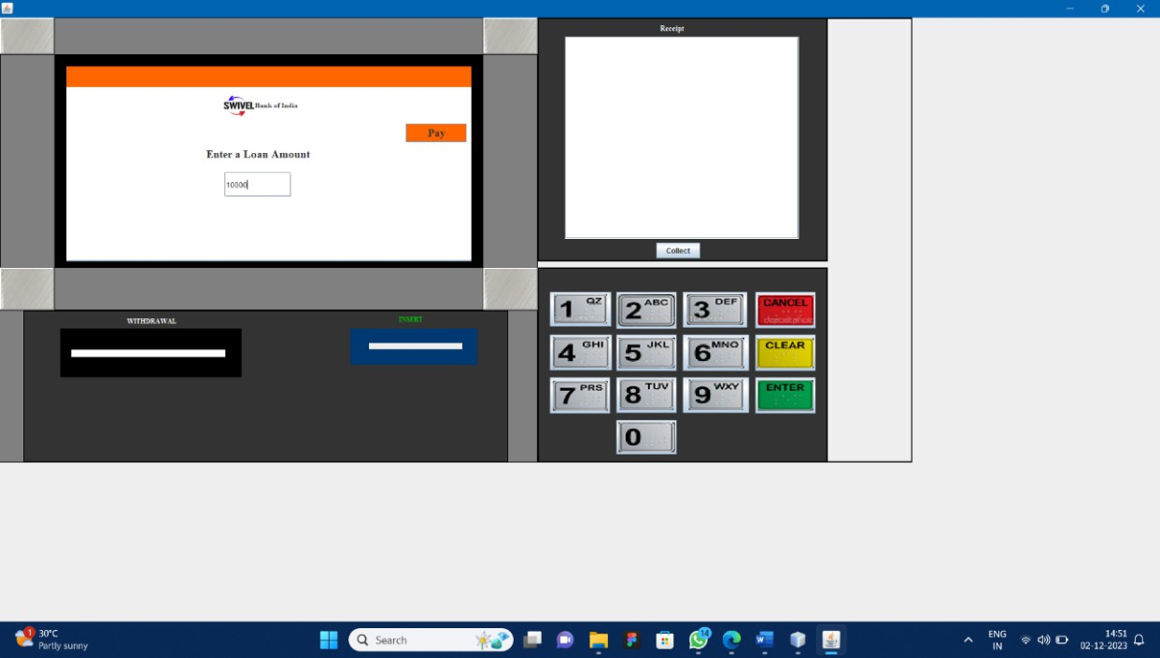

**Fig 4.4.22 house loan page**

* The due amount will get debited and it will show message as “your Transaction has been successful”.

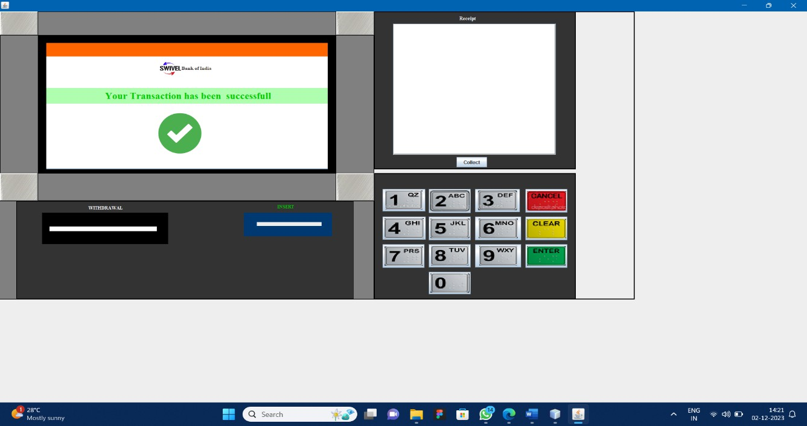

**Fig 4.4.23 Successful page**

* It will ask the user whether they need to print their receipt if they click yes it will print the receipt.

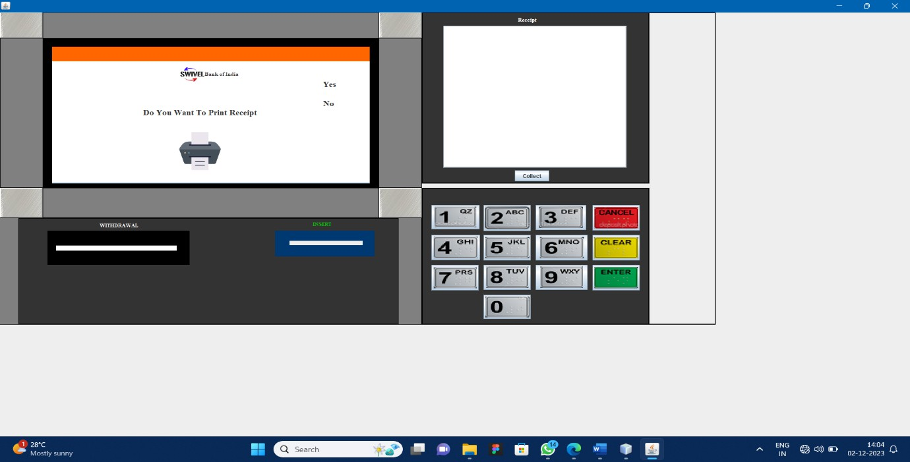

**Fig 4.4.24 Receipt page**

* Ask the user to take out the card and also display the messages “ Thank you Visit again” in the home page.
* If they click No it will ask the user to take out the card and display the messages “ Thankyou Visit again” in the home page.

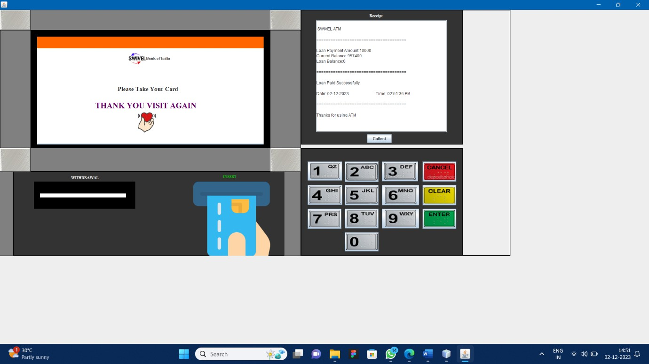

**Fig 4.4.25 Details Page**

## PERSONAL LOAN:

* + If they choose Personal Loan option

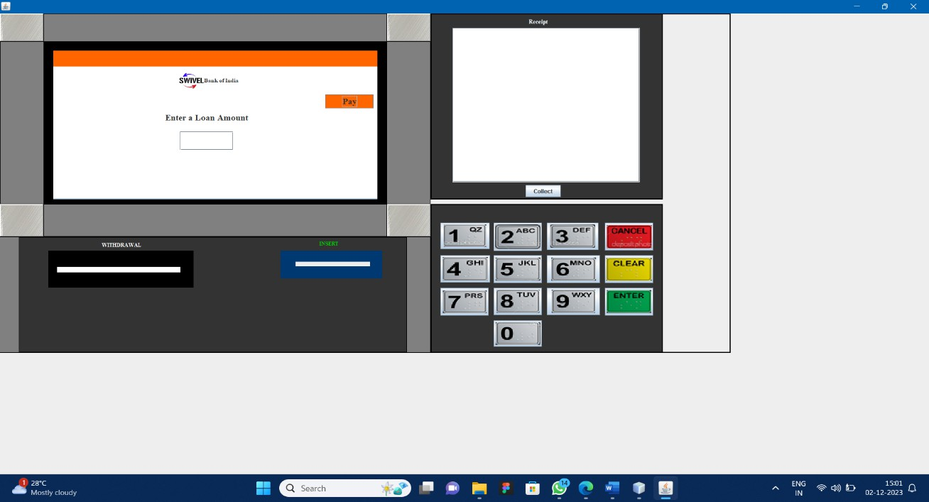

Fig 4.4.26 Personal loan Page

* + It will ask the user to enter the loan amount that need to be paid once click pay option.
  + The due amount will get debited and it will show message as “your Transaction has been successful”.

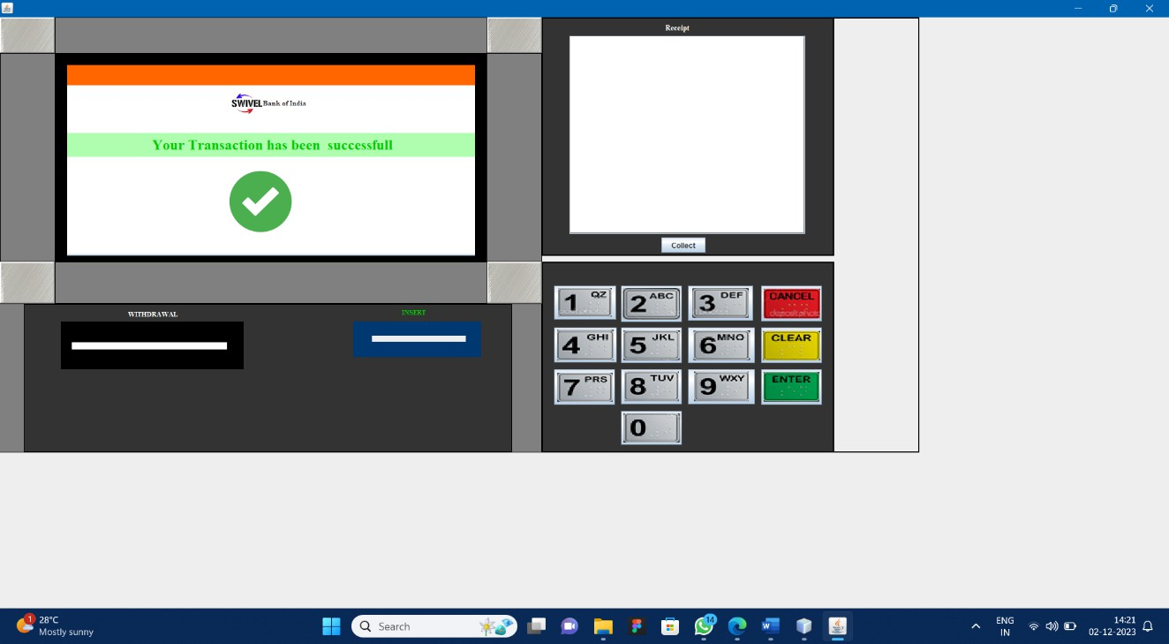

Fig 4.4.27 Successful page

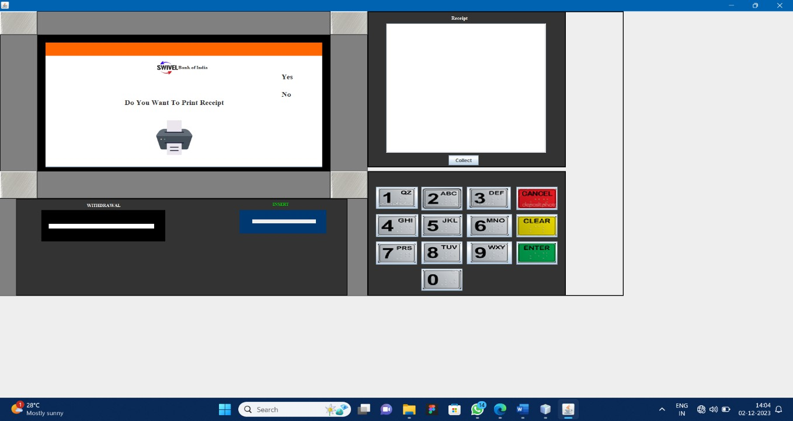

Fig 4.4.28 Receipt Page

* + Ask the user to take out the card and also display the messages “Thank you Visit again” in the home page.

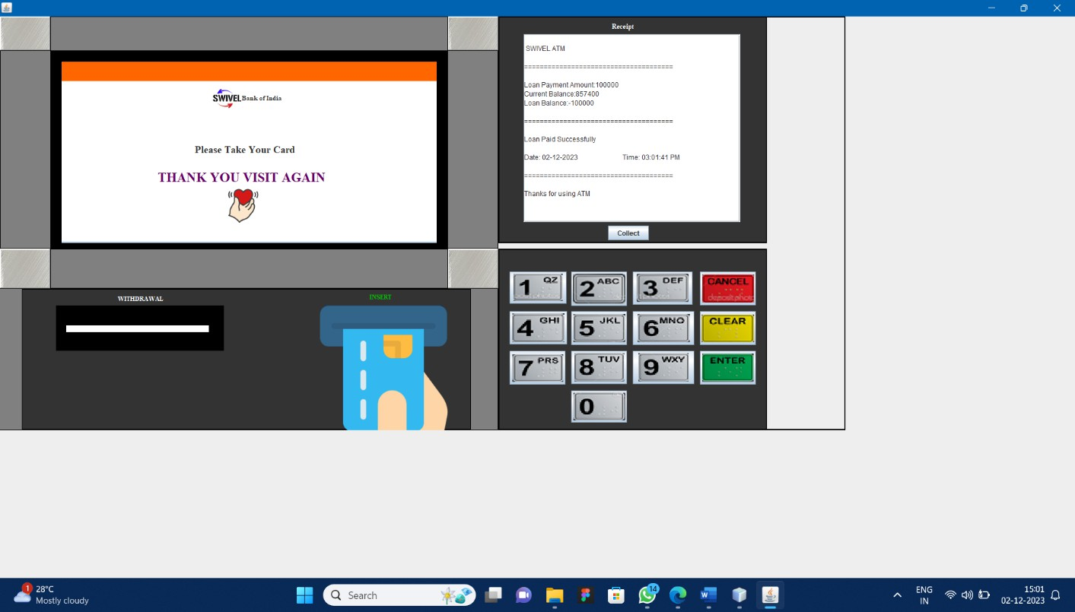

Fig 4.4.29 details page

## BUSINESS LOAN:

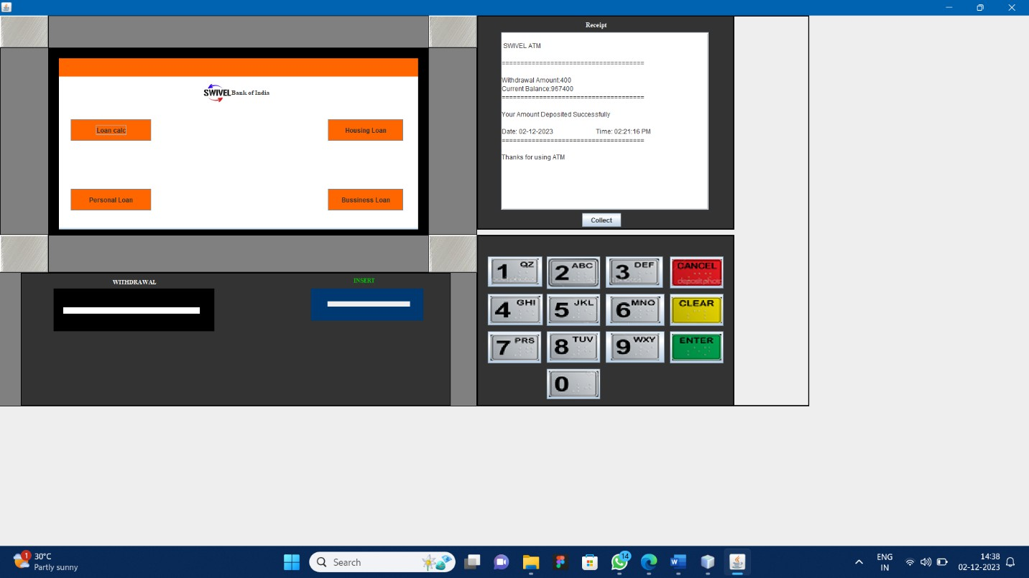

Fig 4.4.30 Module Page

* + It will ask the user to enter the loan amount that need to be paid once click pay option.

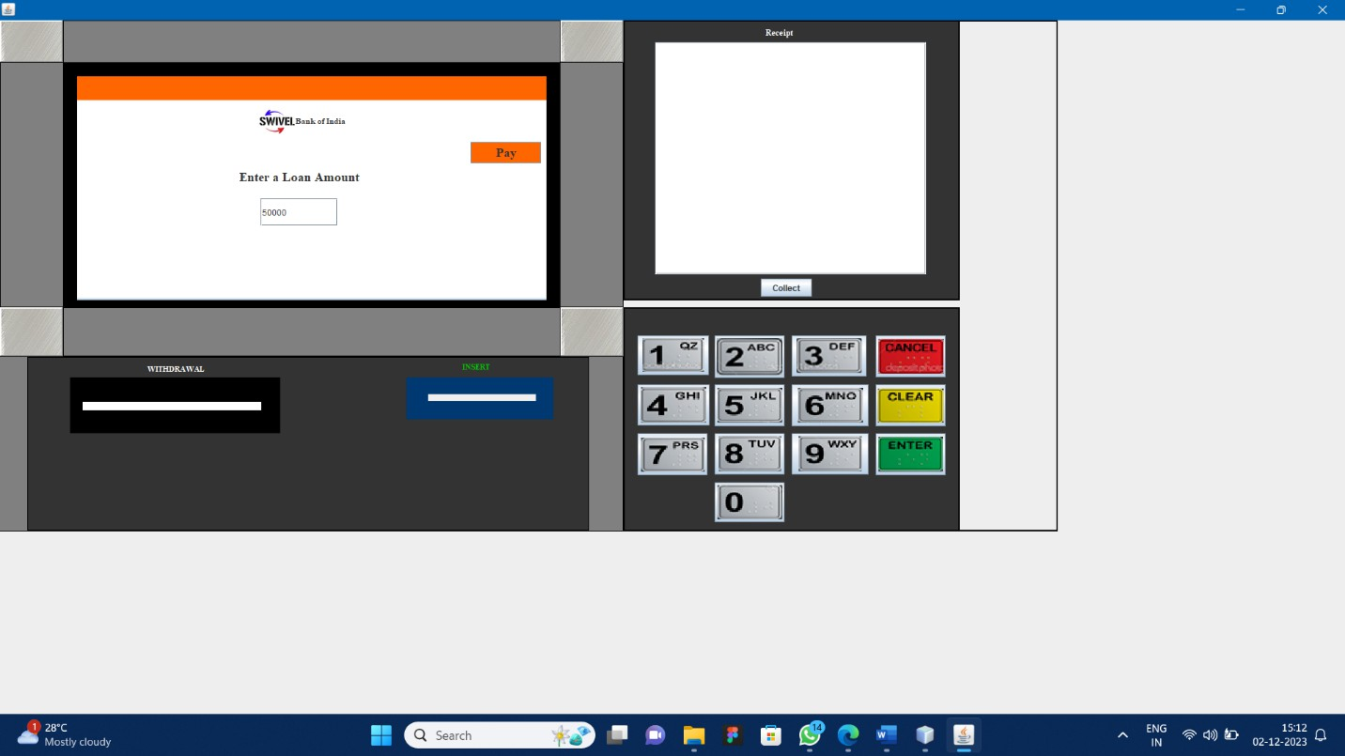

**Fig 4.4.31 Business loan page**

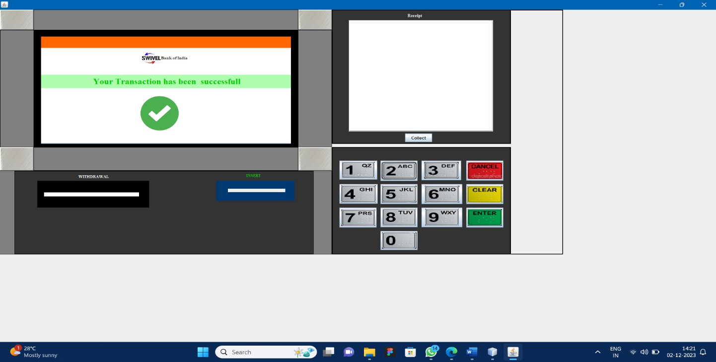

Fig 4.4.32 Successful page

* + It will ask the user whether they need to print their receipt if they click yes it will print the receipt.

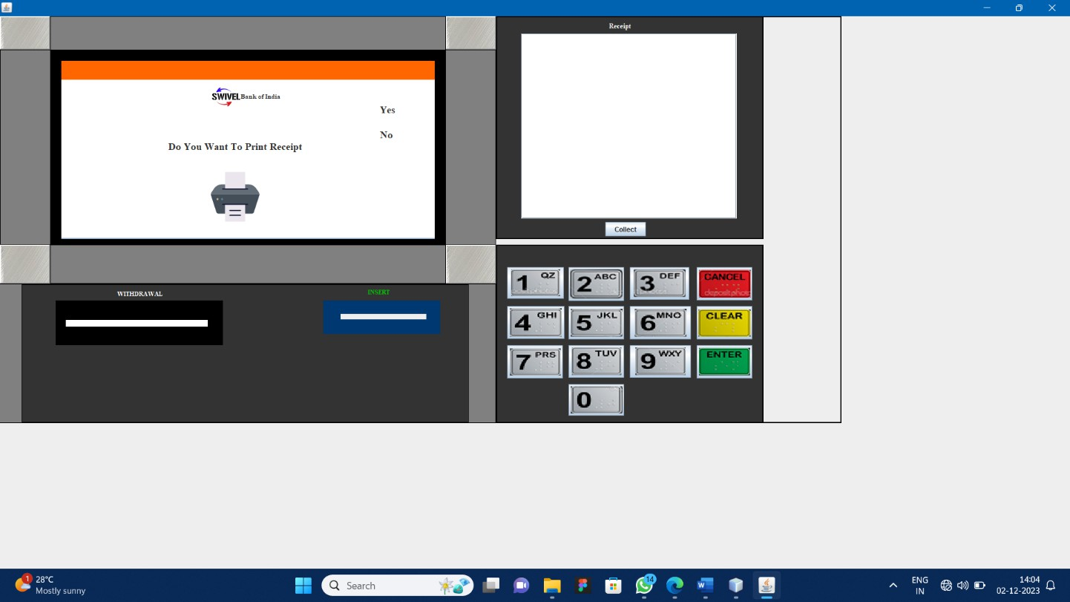

Fig 4.4.33 Receipt Page

* + Ask the user to take out the card and also display the messages “Thank you Visit again” in the home page.
  + If they click No it will ask the user to take out the card and display the messages “ Thankyou Visit again” in the home page.

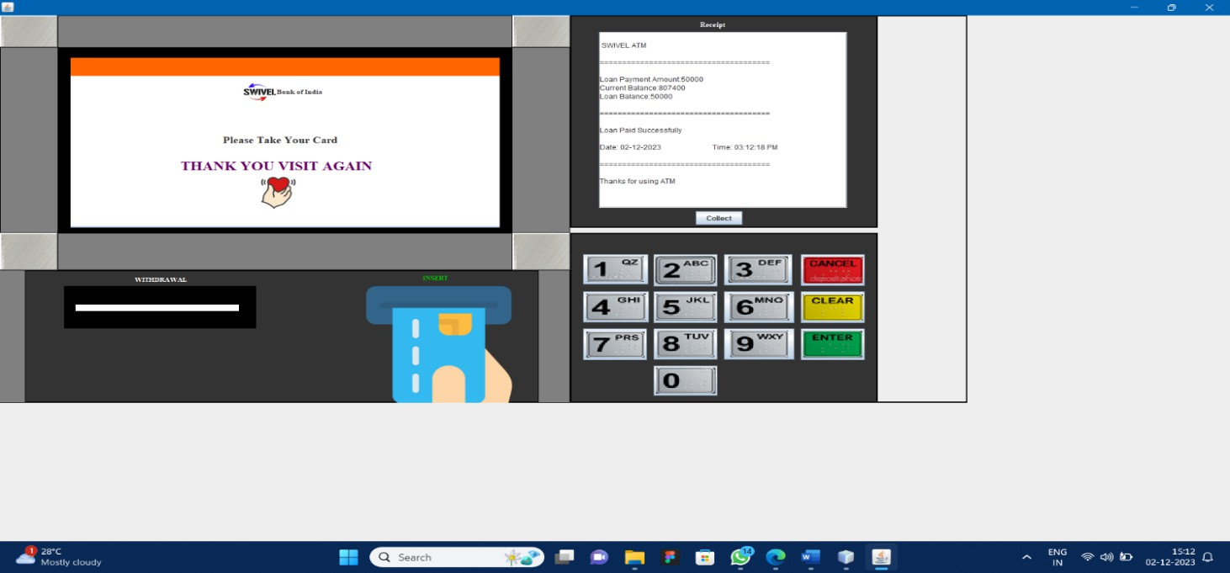

Fig 4.4.34 Details page

* After every transaction database were store the value in table format

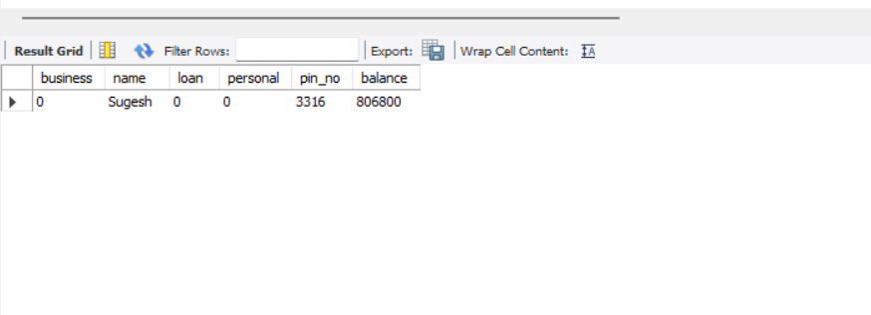

Fig 4.4.35 Database table

# 5.SYSTEM TESTING

**TEST PLAN**

Software testing is a critical element of software quality assurance and represents the ultimate review of specification, design and code generation. The increasing visibility of software as a system element and the attendant “cost” associated with a software failure are motivating force for well planned, through testing.

* + - Testing is the one of step in the software process that could be viewed as destructive rather than constructive.
    - Testing refers to the process of entering inputs into our system under test and validating outputs against our acceptance criteria are if output is okay, our test passes and if output is not okay, our test fails and we have to debug.

## UNIT TESTING

While testing the ATM machine, all levels of testing must be performed on it at the required stages. This means initially Unit testing must be performed on isolated components, followed by integration testing, and later system and performance testing should be performed accordingly.

* + - The details of software functionality & test conditions are satisfied fully on unit based so that choose for black box testing.
    - By incorrect or missing function
    - Applying block box testing in my project “ATM SYSTEM”
    - Interface errors
    - Errors in external database access behavior (or) performance error
    - Initialization and termination error its mainly used for uncover errors in software functions

# 6.CONCLUSION

In conclusion, Banks are now introducing so many ATMs around the globe. The commercial purpose of ATM is to meet the demands of several people like student’s service man, business man and general people. Now its also preferred by the blind man also. The popularity of ATM machine is now increased, because people can avoid theft by keeping lump sum money at their homes. Thus, ATM is one of the gifts from the inventor to humanity and it is the easiest way of depositing and withdrawing money. Transaction is possible at any time in ATMs, that is why in India some people called ATM as "all-time money". Hence it can be concluded that the project titled ATM Management is safe, fast, reliable, convenient and any time accessible money machine.

## FUTURE ENHANCEMENTS:

* + OTP generation.
  + Email and mobile alerts.
  + Active Tracing of Fraudulent activities
  + Security upgrades like Visual Sensors with burglar alarms, Biometric Identification procedures etc.

## ADDITIONAL FEATURES:

* + Loan calculator.
  + Housing Loan.
  + Personal Loan.
  + Business Loan payment.

# REFERENCES

## REFERENCE BOOKS:

1. Alan Beaulieu - “Learning SQL” - 2nd Edition.
2. Bruce Eckel - "Thinking in Java" - 4th edition, 2007.
3. Cay S. Horstmann, Gary Cornell - “Core Java Volume I-Fundamentals” - 11th Edition,1997.
4. Herbert Schildt - “Java The Complete Reference” - 11th edition, 1997.
5. John Viescas - “SQL Queries for Mere Mortals” - 4th Edition.
6. Jesper Wisborg Krogh - “MySQL Connector” – 2018.
7. Kathy Sierra, Bryan Basham, Bert Bates - “Head First Servlets and JSP”.

## WEBSITES:

* 1. Java Documentation @ [https://docs.oracle.com/en/java/index.html.](https://docs.oracle.com/en/java/index.html)
  2. Oracle Java mother site @ [https://www.oracle.com/technetwork/java/index.html.](https://www.oracle.com/technetwork/java/index.html)
  3. Open JDK mother site @ <https://openjdk.java.net/>.
  4. The online Java tutorial @<https://docs.oracle.com/javase/tutorial/.(The> authoritative source).
  5. The MySQL @ <https://www.mysql.com/> .